Q-1. Write an SQL query to print the FIRST_NAME from Worker table after removing white spaces from the right side.
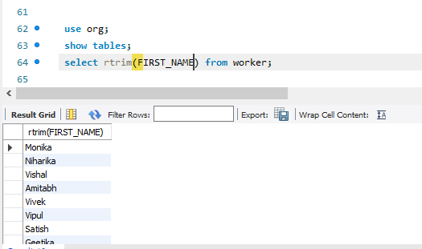

Q-2. Write an SQL query that fetches the unique values of DEPARTMENT from Worker table and prints its length.
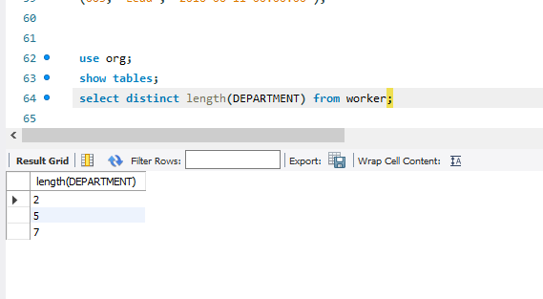
Q-3. Write an SQL query to fetch nth max salaries from a table.
